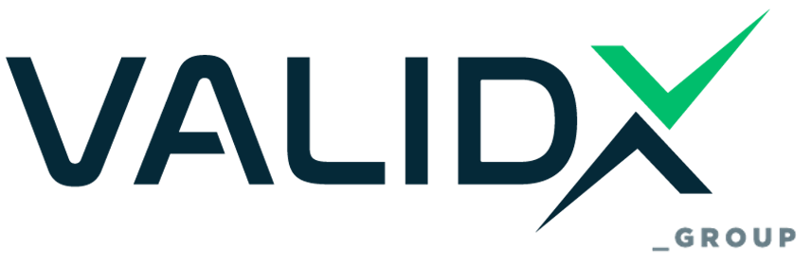

SPECIFIC CERTIFICATION REGULATION
MANAGEMENT SYSTEMS & PRODUCTS

1. INTRODUCTION

The object of VALIDX GROUP conformity assessment services products-services-processes according to the requirements of EN ISO/IEC 17065:2012, is the certification of inspection objects according to the Official Scope of Accreditation (EPED) of ESYD.
This General Certification Regulation defines the responsibilities and obligations of VALIDX GROUP on the one hand and of the customer concerned to certify his products on the other.

2. DEFINITIONS

Inspection: systematic, independent and documented process for obtaining evidence and its objective evaluation in order to determine the extent to which the audit criteria are met

Audit: examining the design of a product, service, process and facilities and determining their compliance with specific requirements

Audit Process: the Process consists of three stages, preparation, conduct and evaluation of results

Certification audit: an audit carried out by an organization independent of the customer and the user, to certify the customer's management/product system

Surveillance inspection: an inspection carried out to verify that the certified management system or product continues to meet the requirements

Recertification Audit: an audit carried out to confirm the continued compliance and effectiveness of the management system or product as a whole, as well as continued relevance in the scope of certification

Non-compliance: non-compliance with the specified criteria of the certified scheme or standard

3. OBLIGATIONS OF THE CUSTOMER

3.1 The customer must make available to VALIDX GROUP at least 15 days prior to the audit (initial certification inspection, surveillance inspection or recertification) all valid documentation related to the Management System (manual, procedures and, if required, work instructions) and possibly a list of changes made since the last audit as well as records of internal audits and reviews by the Administration (if provided for by the certification standard) carried out.

3.2 The customer during the inspection allows and provides the inspectors with access to all files, documents and information (in printed or electronic form related to the scope of certification and ensures that this information is accurate and true. It also allows and ensures the access of inspectors to the relevant organizational / functional units / positions (related to the scope of certification) and generally provides any necessary element and facilitation for the proper provision of the Services by VALIDX GROUP

3.3 The customer is obliged, after the award of the Certificate, to immediately and in writing to VALIDX GROUP all changes in the System and the Processes applied, the legal status, the administration, the structure, the structure, the organization of the Organization, the management and facilities, the operation of the Company related to the certified
activity and generally for any changes that may affect the quality and safety of the products / services it produces or distributes and / or its environmental performance and / or the health and safety of employees and everything that has been, is or can be the subject of inspection and certification in general. It must also announce immediately
and in writing to VALIDX GROUP for the results of third-party audits related to the certified management system. In case it is deemed necessary at the sole discretion of VALIDX GROUP, there will be a re-inspection in accordance with the provisions of the General and Special Terms
Certification Services.

3.4 The Customer is obliged to record all complaints / serious incidents (e.g. product recalls, accidents, compliance with legislative requirements) related to the Management System as well as the way they are managed (investigation of causes, corrections / corrective actions, etc.).
Records must be available to the inspector throughout the inspection for evaluation.

3.5 The customer must also keep and make available to inspectors records of any inspections and findings of other interested parties (Competent Authorities), any complaints and court decisions as well as records that
They concern the way they are managed (investigation of causes, corrections / corrective actions, etc.).

3.6 In order to comply with the requirements of the Accreditation Bodies, the customer must accept the presence of assessors of the Accreditation Bodies during the certification or surveillance inspection. It must also accept the evaluation of files concerning it by the evaluators of the Accreditation Bodies.

4. OBLIGATIONS OF VALIDX GROUP

4.1 VALIDX GROUP is obliged to treat confidentially the information communicated to it or provided by the customer and to use it only for evaluation in the agreed certification scope.
Data and documents of the customer are not disclosed / given in any way to third parties. An exception is the case where a detailed reference to a legal dispute is required, as well as if the non-confidentiality is required by law, administrative act, court decision or generally act or decision of any authority, body or body, public or other,
in any jurisdiction, jurisdiction or proceeding.

4.2 VALIDX GROUP acts with reasonable diligence, skill and care and undertakes in its judgment to apply exclusively the scientific, technical, empirical and logical rules applicable in this regard, while
It is not bound by orders, instructions and suggestions of the client for the exercise of its duties.

4.3 VALIDX GROUP is obliged to notify the certificate holder of significant changes in the certification process that affect him, immediately.

4.5 VALIDX GROUP must record customer complaints related to the certification process and inform the Impartiality Committee mainly of well-founded complaints. In case the customer formulates
complaint about the services of VALIDX GROUP and the natural persons representing it (e.g. delays in issuing certificates, bad behavior, etc.), the recipient is obliged to record (in case of an oral complaint), or to receive the written information of the customer on the
complaint and forward it to the Director of the organization and to the Quality Manager. The Director decides on the action to investigate the complaint in order to take corrective action, which is approved by the Management of

5. APPLICABLE LAW

The interested parties unreservedly agree to submit any dispute arising from this Regulation to the exclusive jurisdiction of the courts of Athens. This Regulation is subject exclusively to Greek Law.

6. AMENDMENTS
Edition | Chapter | Cause & signs of modification | Drafted by | Approved by | Date
v.2 -> v.3 | Overall | Format Change and Group Structure Information Showcasing the relationship with the new entity VALIDX and the IMS Implementation | Athanasios Arvanitis (Quality Manager) | Angelos Koulouridis  Stergios Zarifidis  Sara Pellegrino | 13/05/2025

